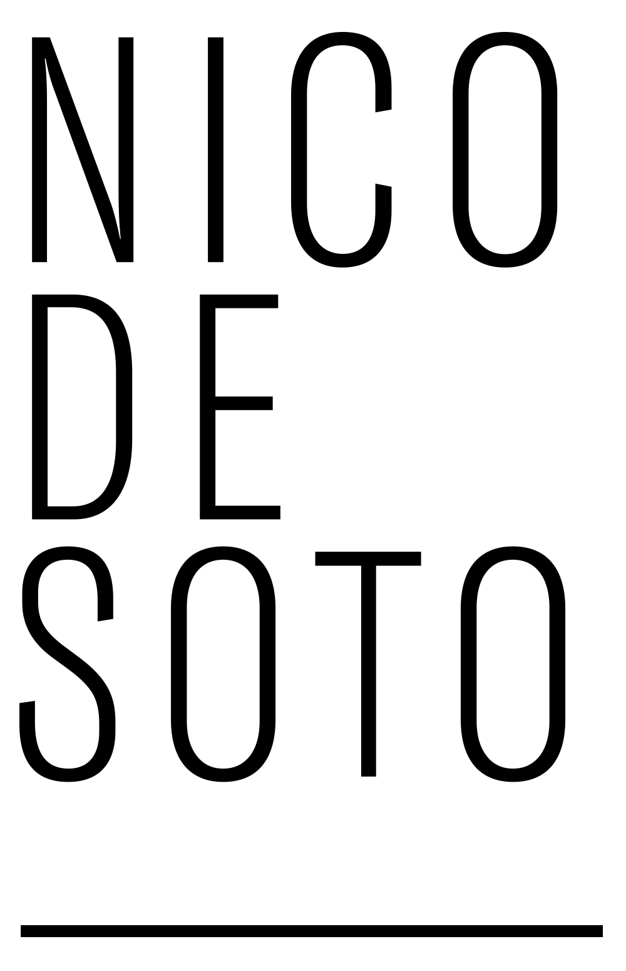

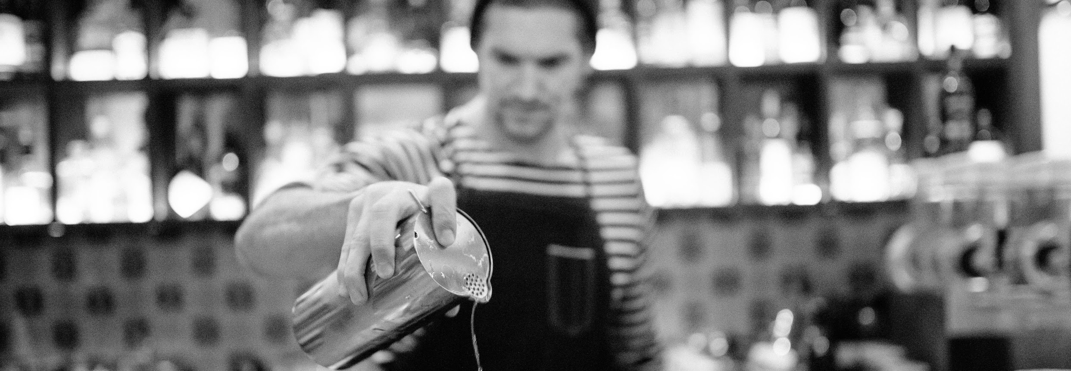
Hot links
2010
. The Dizzy Fizz
. Serious Eats
. The New York Times
. Reuters
. Reuters

2011
.Reuters

2012
. jrgmyr
. eG Forums
. Eater NY
. The New York Times
. The Washington Post
. Guest of a Guest
. Port
. New York Mag
. New York Mag

2013
. First We Feast
. Starchefs

2014
. Difford's Guide

2015
. Martell 300
. Imbibe
. NBC New York
. The Washington Post
. Time Out NYC
. Lonely Planet
. The New York Times
. Washington City Paper
. Town & Country
. Bloomberg
. Time Out NYC
. AM NY
. Time Out NYC
. Alcohol Professor
. AM NY
. Time Out NYC
. Coveteur
. Punch
. Time Out NYC
. The New York Times

2016
. Institut Français Israel
. My Little Tel Aviv (Israel)
. Le Cocktail Connoisseur
. Wine Enthusiast
. Omnivore
. Radio Canada
. Drink Planet (Japan)
. La Presse + (Canada)
. Manhattan Sideways
. Parisbouge
. Barstalker (Germany)
. Spiegel (Germany)
. 52 Martinis
. O Nouvel Obs
. Thrillist
. Financial Time
. InfosBar
. Rumporter
. Atabula
. Vice
. Rumporter
. For Georges
. Saveur
. InfosBar
. For Georges
. Quaff
. Saveur
. Thirsty
. Thrillist
. Zenitude Profonde
. VinePair
. Tales of the Cocktail
. Cook's Illustrated
. Quaff
. Bravo
. Forbes
. BlackBook
. Tasting Table
. L'Express
. For Georges
. Le Monde
. So Food So Good

2017
. Australian Bartender
. Food & Wine
. Telerama
. The New York Times
. Supercall
. The Good Life
. Event Bu (Japan)
. Punch
. Lan Kwai Fong (Hong Kong)
. Saveur
. Thrillist
. AirBnB
. Pointy Snout
. L'Express
. Cocktails and Bars (Australia)
. Quaff
. Phaidon
. Sophic Society
. Le Figaro
. Redvisitor
. Redvisitor
. Redvisitor
. Australian Bartender
. Time Out NYC
. Australian Bartender
. Thrillist
. Time Out NYC
. Thirst Mag
. Imbibe
. AD Magazine
. Seven Fifty Daily
. The Handbook
. Difford's Guide
. Departures
. #UnPaysOùJaiAppris
. Late Night with Seth Meyers

2018
. Australian Bartender
. Barometer (Russia)
. Time Out NYC
. Punch
. Cosas (Peru)
. Ocean Drive
. Fair
. VinePair
. Quaff Magazine
. Conde Nast Traveler
. La Boîte à Cocktails
. Punch
. Miami New Times

2019
. Conde Nast Traveler
. InfosBar
. Pure Wow
. Town and Country
. Barmag
. IOL (South Africa)
. The New York Times
. Time Out Miami
. Punch
. PR Newswire
. Forbes
. Business & Marchés
. Sortir à Paris
. 9 Confidentiel
. For Georges
. Daily Beast
. Le Bien Public
. Speakeasy

2020
. Time Out Paris
. For Georges
. Cocktail Courier
. On The Back Bar
. Thirsty
. VinePair
. Punch
. ChefsFeed
. Quaff Magazine
. Business & Marchés
. Time Out Paris
. BarMag
. Nouvel Obs
. Chefs d'Oeuvre
. French Craft Guild
. Business & Marchés
. The World's 50 Best
. Le Parisien
. BeMixo
. Liquor.com
. Time Out Paris
. Cocina y Vino
. Cointreau
. Robb Report

2021
. NY Times
. Eater
. NY Post
. Forbes
. Resy
. Thirsty
. City Tour NY
. Time Out NY
. Town & Country
. Time Out NY
. Time Out NYC
. Punch Drink
. Cocktails Distilled
. Forbes
. Time Out NY
. Insider
. Time Out NY
. Campari Academy
. The Single Table
. Villa Schweppes
. BevNet
. Imbibe
. Food & Wine

2022
. Vinepair
. Do it in Paris
. The Spirits Business
. Indulge Express
. The Honeycombers
. Bali.com
. Hotelier India
. The World's 50 Best
. The World's 50 Best
. Mathieu Teisseire
. Questa Mia Milano
. Business et Marches
. Robert Simonson
. Grazia
. L'Equipe

2023
. Roadbook
. Punch
. The Spirits Business
. Vinepair
. The Spirits Business
. Delish
. Plavakamenica
. The World's 50 Best
. The Spirits Business
. Le Monde

